**VIISA Course 2, Preschoolers in Center Based Settings**

**Agenda**, **Session 1**

**Day 1: November 6, 2024**

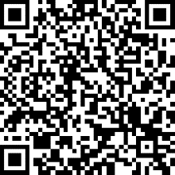

1:00 Getting Started – take the pre-test!

1:30 Introduction to Vision Impairment

2:30 Medical Aspects and

Implications of Eye Conditions

3:30 Break

3:45 Keeping the Family Involved

Pre-Test!

4:15 One Minute Paper

4:30 Dismiss

**Day 2: November 6, 2024**

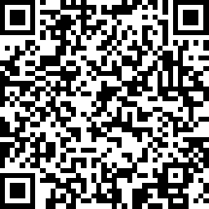8:15 Review One Minute Papers

8:30 Cultural Competency

9:15 Activities of Daily Living

10:45 Break

11:15 Cerebral/Cortical Visual Impairment (CVI)

12:30 Working Lunch – CVI bookmaking

OMP!

1:30 Clinical Vision Assessment

2:00 Learning Media Assessment

2:45 Break

3:00 Working with Preschoolers

with Vision Impairments

3:45 One Minute Paper

4:00 Dismiss



**Day 3: November 6, 2024**

8:15 Review One Minute Papers

8:30 Developing Language

10:00 Break

Post-Test!

10:15 Literacy

Concept Bookmaking Activity

12:00 Working Lunch – MoSPIN

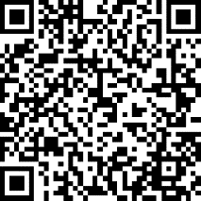1:00 Introduction to and Getting Ready for Braille

Slate and Stylus Activity

2:15 Break

2:30 Social Skills

3:00 Visual Modifications in the Preschool

3:45 Wrap-up, Post-test and Evaluation

Evaluation!

4:15 Dismiss